Jake Aldridge - Down
For immediate release.

“Jake’s found a brilliant hook with his new song ‘Down’. The play on words makes this a must listen! I love it.” Keith Greentree, The Big Country Show, BBC East Radio

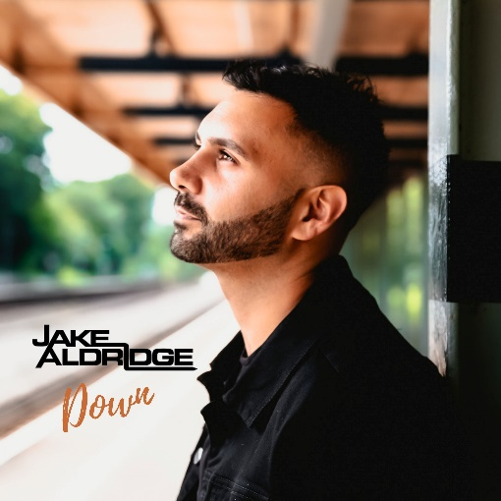
Rapper-turned-singer Jake Aldridge is one of the most intriguing British artists in recent years. Despite starting his career with a lack of natural rhythm, he went on to become an award-winning musician picking up multiple awards in the best artist category. Wishing to inspire those facing adversity, Jake’s upcoming Pop-Country single ‘Down’, is a tribute to, and a celebration of, ‘The underdog’. A title he is all too familiar with.
Set for release on 17th September

At 11 years old, Jake experienced a traumatic loss when his father was struck by lightning during a family fishing trip. The tragedy became the catalyst for a budding career in the music industry as he began writing songs as a way of expressing himself. Living in Reydon (a small coastal village in Suffolk) Jake began collaborating with local music producers who helped him to discover a sense of rhythm.

Eventually, Jake began to release songs into the public domain. His singles ‘Erotic’ and ‘Falling’ received regular rotation on Sky’s Playboy television channels. Jake’s music ultimately caught the attention of Dingwall’s owner Maria Kempinska, who invited him to perform at the London Hippodrome where Grammy award winner Billie Laurie said that the young rapper “Definitely has hit songs”!
After receiving more votes than 100 fellow artists, Jake picked up the ‘Audience Choice’ Award at the 2017 ‘New Music Generator Awards’. He also won the ‘Male Act of the Year’ Award at ‘The International Achievers Awards’ the following year. As the momentum began to build, Jake’s music was selected for licensing by ‘Road Trip Nation’ (a US television series). Whilst receiving critical acclaim for his hip hop-influenced sound, it was the country-pop genre that began to peak Jake’s interest. Inspired by American country artists, such as Kane Brown & Dan + Shay, Jake decided to take singing lessons and began incorporating country music into his songs. The new sound helped Jake to secure airplay on BBC Radio Suffolk and BBC Radio Cambridge. His Pop-Country songs have amassed 70,000 streams on Spotify to date.

Jake embraces the joviality of pop and combines it with a splash of country in his new track ‘Down’. The evocative song is filled with raw honesty, genuineness, and sincerity for the underdog. The track is produced by Nashville based Simon Reid and was co-written by multi-instrumentalist David Edward Booth.
“I’ve always wanted to write songs that are close to my heart. Songs with a meaning that I believe in, and a message that I can stand for. I hope that my achievements (despite the odds being stacked against me) will help remind others to never give up and that anything is possible”. - Jake Aldridge.

Click here to listen to ‘Down’

Email: jake@jakealdridge.com Phone: 07427 632158
Website: www.jakealdridge.com / EPK: https://jakealdridge.com/press-kit/
Social Media:
Spotify
SoundCloud
Instagram
Facebook
YouTube
Twitter

